# CUSTOMER ENGAGEMENT MARKETING BMT6144

**Trimester - 4**



# CASE STUDY: STARBUCKS WINNING BACK ITS LOST CUSTOMERS AFTER ECONOMIC SLOWDOWN 2008

**SUBMITTED TO Dr SAJU B**

# ASSISTANT PROFESSOR VIT BUSINESS SCHOOL

**SUBMITTED BY RADHIKA G (20MBA1028)**

# INDEX

|  |  |
| --- | --- |
| **Content** | **Page** |
| **1.** Methodology Adopted | **3**  **3** |
| **2.** Definition:  (Customer Churn & Win back Strategy) |
| **3.** Case Study - Starbucks | |
| **3.1** Case History – Starbucks during 2008 Economic Slowdown | **3** |
| **3.2** Perceptual Map  Content: Positioning, Target Audience, Brand Relationship | **4** |
| **3.3** Competition & Win-Back Strategy Adopted  Content: Co-Creation, Community Involvement Concept, Mobile App, Social Media Strategy | **5** |
| **3.4** – **3.6** Focus Questions: justifying profitability of win-back strategy adopted  Content: Profitability, Customer first-life time, second-life time, CLV  & CAC calculation) | **6-9** |
| **4** Conclusion | **9** |
| References & Plagiarism Check | **10-11** |

1. **Methodology adopted:** Several resources were utilized in summing up the views from different case studies few target questions were answered. Kindly find the reference material links at the end of this document.

# Definition: Customer Churn & Win-back strategy

A calculated marketing plan to get those DAUs who dropped off back on the business, retain them as active users, and help keep the churn rate low. Churn rate, the percentage of defected customers during a given period, is detrimental to the success of the business. Re-engaging an inactive user can assist improve the bottom line because acquiring a new client can be up to 25 times more expensive than retaining an existing one. It's still critical to invest effort into obtaining new users or customers in order to expand, but it's also critical to keep adding value to the existing customers in the database. **Win-back campaigns and strategies are an effective way of reinvigorating the dormant users, helping improve the customer lifetime value.**

# Churn Rate:

To understand the profitable customers, Monthly Active/ Daily Active users should be studied.

# Monthly Churn Rate = Users Lost in this Month / (Users at the beginning of the month + users added this month)

Some of the reasons why a customer turns into defected customers

* + Bad customer service.
  + Not enough value: The biggest reason customers leave is not, in fact, because they found a better price.
  + Poor quality communications.
  + No brand loyalty.

1. Case Study: Starbucks Winning Back its Lost Customers After Economic Slowdown 2008

# Starbucks during 2008 Economic Slowdown:

While its quality is undisputed, its cost has always been higher than that of domestic coffee shops in numerous countries. This was one of the reasons why the company suffered during

the 2008 economic downturn, as customers sought out cheaper alternatives for their daily coffee. Starbucks was forced to close 600 locations that were not profitable. Howard D. Schultz replaced Jim Donald as CEO of Starbucks in 2008, following an eight-year absence. They were swept up with their lack of focus. Starbucks' most devoted customers began to notice faults in quality and service, and they began seeking out smaller coffee shops that were entirely interested in providing a fantastic cup of coffee. Starbucks eliminated 18,000 workers, shuttered 977 stores, and saw a 7% drop in same-store sales. The stock price has dropped to

$7.83 from $39.63 in 2008.

# Perceptual Map:

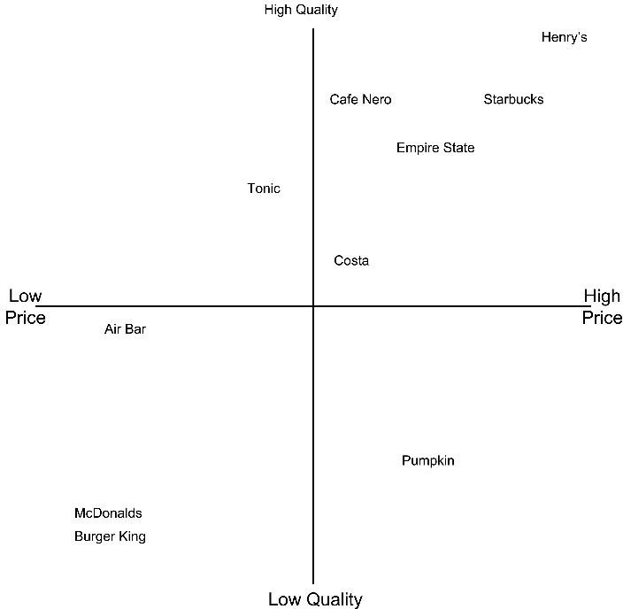

*Figure 1 Sourced from Ads & Brands, Five Sevens*

The above picture indicates the positioning of Starbucks where it implies a premium charging for the customer by proving the “Third Space”. Starbucks' goal is to deliver a new, fresh, and enjoyable experience through excellent service. Their mission statement is to deliver the greatest coffee, give the best environment, provide the best service. They positioned themselves as a wonderful and reasonably priced coffee business that would serve delicious and rich coffee to clients. **The Initial Relationship with the Customer: Friendship, Loyalty, Passionate.**

With the mono-segment positioning, Starbucks focuses on star customers who are willing to pay the premium for the luxurious service offered. While its quality is undisputed, its cost has always been higher than that of domestic coffee shops in numerous countries.

# Competition & Win-Back Strategy:

After reviving from the recess, Starbucks witnessed that the rapid expansion has distracted it from addressing the problem. Adding to the woes, the company had to face competition from many cheaper alternatives including from the Gian Fast Food Chain McDonalds’s Espresso. Death Wish Coffee and many other online coffee services popped up during this period. Apart from the stated particulars, the existing giants. Thus, the only way for Starbucks was to reignite the emotional attachment with customers.

**Community Involvement Concept:** They have redone their store layout in the process of restoring their ambience. This phase attracted its loyal customer back to enjoy the third space once again. Also, the investment in technology made operations and point-of-sale processing smoother that employees feel motivated which ended up in the community involvement.

**Co-Creation:** In order to rebuild the customer relationships and prove that it cared for them through quality & consistency, Starbucks created co-creating opportunities. It rolled out the “My Starbucks Idea” through which customers can directly contact the representatives. This move ultimately ended up in creating like-minded communities: ‘Free Wi-Fi group’ or ‘Comfy Chair Group’. Additionally, the coffee chain was able to implement 100 + creative ideas, restoring brand trust among customers.

Starbucks has used every possible opportunity to make its customer engage. **#RedCupArt** is one such initiative taken up to let customers sketch unique designs on plain red cups as canvas and share them via Instagram/Twitter. This contributed to customer social influence value through **positive word of mouth.**

**Mobile Apps (2017):** As mentioned before, Starbucks had a great deal of investment in technology. They have entered the mobile phone application space well before their competitors. This was a great leap considering the bottom line of the coffee chain. However, the application still encompassed the store-locator and ‘nutrition-based information’ along with the feature to order online. The home-delivery service option had its utmost relevance in the course of the pandemic. In this case, the ambience/experience is now witnessed as an online store attribute and happy taste/delivery experience. In the first place, the app was designed to appeal to its target audience and form an online community. The engagement is possible was ensured via reward programmes.

**Social Media Strategy & Creating Trends:** The promotions encouraged the idea of having a casual breakfast at Starbucks which significantly increased the customer visits around 10.30 am. Not only did this created the online-order-traffic but people across America queued up at the outlets.

**Product-Based Campaigns:** With the co-creation, Starbucks invents new flavours and celebrates them with customers via online campaigns: They have created social accounts for pumpkin spiced latte and Frappuccino, where they post relevant memes for their diehard fans.

**Social Message:** Besides altering the internal competencies, their digital presence and contributions are held for good cause: For instance, #ExtraShotOfPride campaigns support the LGBTQ+ community.

# Would it have been profitable for Starbucks if it had decided to sell low-cost coffee because of the economic downfall?

Though it might generate sales volume, the customers who have got addicted to the comfiness of Starbucks might feel betrayed. This would also mean, risking the adherence to the bottom line. So, instead of winning back its lost customers, it would have hurt the feelings of its die- hard fans.

# How do first-lifetime CLV affect the winning back of a customer?

First Lifetime Defection Period Second Lifetime

Prospect Acquired as Brand-New Customer

Customer Defected

Customer Reacquired with a win-back offer

Customer may defect again

*Figure 2 Customer Journey*

Complaints from customers, service recovery and recommendations are all examples of first- life consumer experience. Most of the time, the reason for defection (Price/ Quality/ Customer service/ mix of attributes) were not understood and this might cause the win-back strategy to

not be relevant to the customer. The customer's first-hand experiences and behaviour (complaints, service recoveries, and referral behaviour), as well as the reason for defection, will affect whether the lost customer believes the decision to return to the firm is a sound one. Numerous studies have found a direct link between first-life-time-value and the likelihood of regaining a client. Ganesh, Arnold and Renaldas (2000) prove the hypothesis. Morgan & Hunt (1994) explain that trust and risk are interlinked. When the customer left for the cheaper options, there was a valid reason. Now, faced with win-back campaigns of Starbucks, the risk factor is also involved in their perception when they have to switch the service provider.

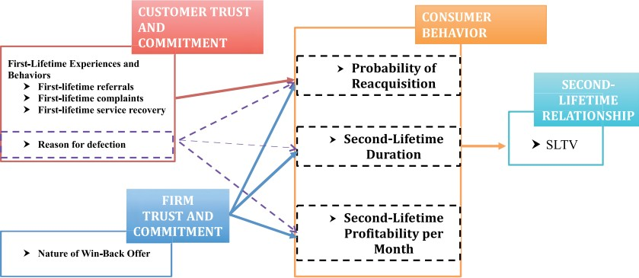

*Figure 3 Conceptual Framework by V.Kumar et al.*

# List out few alternative Win Back Strategies along with the evaluation of profitability.

To answer the above question: Let’s take two scenarios

# Starbucks- Actual Recession Case

|  |  |
| --- | --- |
| **Factors to Consider Before Choosing a Win back strategy** | |
| Initial Customer Lifetime Value /  Relationship | High |
| The Reason for customer defect | Recession & Cheaper alternatives |
| Would it be profitable to win back the  customer? | Yes, as its loyal customers have high CLV and are STAR  customers. |
| Win-back Strategies utilized by  Starbucks | Social Media Community Programmes, Innovation in Products,  Investment in technology (The investment in technology |

|  |  |
| --- | --- |
|  | indirectly helped customers as it let Starbucks representatives provide seamless happy experience) & Co-Creation. The evaluation of profitability is demonstrated in the previous section.  In case if few customers are still persistent about their choice of shift with competitors, for instance: Low price has only become the only motto of the lost-customer, then the company has to take the call. It has to know if the person has stopped being its  customer. |

* + 1. **Other strategies as an immediate response to losing die-hard-fan-customers include**

|  |  |  |
| --- | --- | --- |
| **Factors to Consider Before Choosing a Win back strategy** | | |
| Initial Customer  Lifetime Value / Relationship | ( Negative CLV ) | Premium Member – Eg. Platinum Customer (Highest CLV) |
| The Reason for  customer defect | Example: Customer left after  one-time-purchase | The customer left due to a bad experience |
| Would it be profitable to win back the customer? | According to a referral advertisement in **Starbucks China:**  CAC = ¥ 40 + 10% discount on first coffee order  Low CSV -> No word of mouth or new customer acquisition  Customer-Second-Life-time- value = might below as well | **Starbucks China:**  CAC = ¥ 40 + 10% discount on first coffee order Eg: if the first order (relative to second life-time) = ¥ 26  **From Pareto Principle (80:20 rule –** Assuming the customer belongs to ‘20%’ category: I,e he is an everyday-customer**)**   * 10% discount → ¥ 2.6 * CAC = 2.6 + 40 = ¥ 42.6 * Membership Card Cost = ¥ 17.51 CLV =   𝐵𝑎𝑠𝑒 𝐺𝑟𝑜𝑠𝑠 𝑀𝑎𝑟𝑔𝑖𝑛 𝑝( 𝐵𝑢𝑦 = 1)𝐺𝐶  ∑𝑇 + ∑𝑇  𝑡=1 𝑡=1  (𝐼 + 𝑑𝑖𝑠𝑐𝑜𝑢𝑛𝑡)^𝑡 (𝐼 + 𝑟)^𝑡  – Marketing Cost/ (1+r)^t |

|  |  |  |
| --- | --- | --- |
|  |  | CLV = 17.51/ (1+0.1) + 0.9 * 468 / (1+0.1) – 330/(1+0.1)  **CLV = ¥ 104.366** → **High CLV**  In the case of High Customer Influence value, the customer might bring in new customers. |
| Alternative Win- Back Strategy | **Personalized E-mails:** this technique can also be automated with conversational AIs. No loss will be incurred even if the customer chooses to ignore the offer as AIs only involve  one-time installation costs. | * Referral Code * Rewards during Birthdays to showcase that Starbucks still cherish the customer – A state of apology to win back lost intimacy, * Ability to send gifts to their close people, Denoting them first about the new variant release |

# Conclusion:

For a company that is known for providing third space and experience, it was difficult to shift its services online. But customer-centricity is to be never forgotten. When Starbuck deviated from the focus and expanded its presence offline without analysing the value proposition, it significantly lost its customers. Thus, after the recession, with its sophisticated product design, service up-gradation and social-media consumer engagement practices, it won back the hearts of its loyal customers and new customer’s as well. As indicated in the report, customers are having a ‘Friendship’ relationship with the brand which made the chain post memes and be the trend. The customers during the recession who had left for the cheaper options cannot possibly resist the goodness of Starbucks. Thus, the success of the win-back strategy is significantly influenced by the first-life-time experience due to the history of trust. However, the second lifetime experience can be regulated purely via retention techniques while keeping the customer churn low.

# References:

Regaining “Lost” Customers: The Predictive Power of First-Lifetime Behavior, *California State Polytechnic University,* V. Kumar (2015)

Case Study: Star Bucks Coffee GRC 411, Karthleen Lee

An Analysis On Brand Loyalty: A Case Study On Starbucks, *Spring, California State Polytechnic University*, Kavita Kumar (2016)

Recapturing Lost Customers, World Scientific, Journal of Market Research Jacquelyn S. Thomas, Robert C. Blattberg, Edward (2004)

[Referral Post](https://www.google.com/search?q=starbucks%2Breferral%2B&tbm=isch&ved=2ahUKEwiY0Jvj3IHzAhVEAisKHSYBBdEQ2-cCegQIABAA&oq=starbucks%2Breferral%2B&gs_lcp=CgNpbWcQAzIHCCMQ7wMQJzIHCCMQ7wMQJzIECAAQHjIECAAQGDIECAAQGDIECAAQGFDq7wFYzPoBYLODAmgAcAB4AYABhwGIAe8GkgEDOS4xmAEAoAEBqgELZ3dzLXdpei1pbWfAAQE&sclient=img&ei=90pCYdj4HcSErAGmgpSIDQ&bih=722&biw=1536&imgrc=ibevHU90BH1soM)

<https://www.instagram.com/p/_c--AzxcwU/?utm_source=ig_embed>

<https://stories.starbucks.com/stories/2016/starbucks-invites-customers-to-create-red-cup-art/>

[https://digital.hbs.edu/platform-digit/submission/starbucks-winning-on-rewards-loyalty-and-](https://digital.hbs.edu/platform-digit/submission/starbucks-winning-on-rewards-loyalty-and-data/) [data/](https://digital.hbs.edu/platform-digit/submission/starbucks-winning-on-rewards-loyalty-and-data/)

<https://www.reuters.com/article/us-starbucks-idUSWNAS851720080131>

(Next Page: Plagiarism Report)

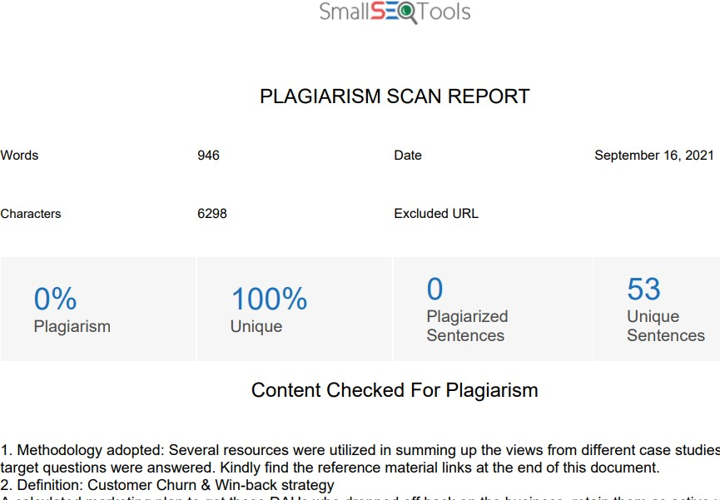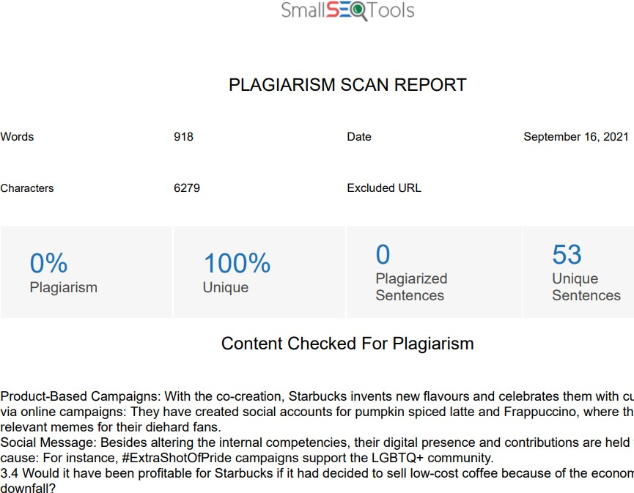

# Plagiarism Report:

**Sections: 1 – 3.3: 946 Words Sections: 3.3 continuation – 4 : 918 Words**